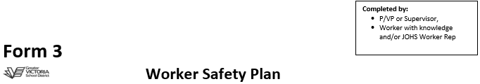

  Form 3 Details:
  Created for: All workers that directly work with student or other
  Worksite:
  Parties Responsible for Plan Creation:
  P/VP or Supervisor:
  Worker:
  JOHS Worker Rep:
  Date:

  Form 3 Created For:
  Student:
  Grade:
  Phone #:
  Parent/Guardian:
  Other:
  Phone #:

Overview of Past Behaviour |  | First-time occurrence |  | Follow-up to previous occurrence(s)
Antecedents (Root Causes):

Actions to Address Behaviour

Actions to take to avoid escalation: | Position Responsible | Implementation Date
1.
2.
3.
4.

Actions to take in escalated situations:
1.
2.
3.
4.
(add additional steps as needed)

  Committee Member Sign-off:
  P/VP or Supervisor: ______________________
  Worker: ______________________________
  JOHS Worker Rep: ______________________
  Scheduled Review Date: ________________________
  -Ensure first review is conducted, within, 1 month after incident and at the beginning of each school year thereafter.
  -Please note any review changes to plan on reverse side of this page.

