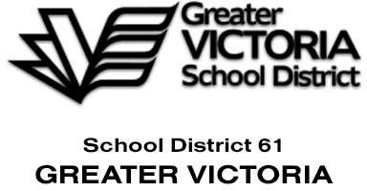**Encountering Waste Items on School Grounds**

Waste items refer to discarded items or materials that may be encountered on our school properties, particularly in urban areas. This can include personal belongings, food waste, needles, pipes and other potentially hazardous materials.

Safety Measures

1. **Identify**: Be vigilant in identifying potential hazardous waste. If you come across any suspicious items, do not touch them with your bare hands.
2. **Notify**: Immediately inform your supervisor or administrator and they will arrange its disposal through appropriate channelsby people trained in the safe handling of bio hazardous material.
3. **Isolate**: Secure the area around the waste to prevent accidental contact by students or other workers. Use cones or tape as necessary. While retrieving materials, ask another employee to monitor if possible.

Remember, your safety is paramount. If you see something, report the hazard and take steps to control the risk to others until it is controlled. It takes teamwork to keep our schools and each other safe.