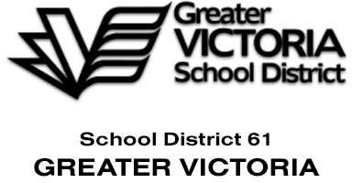**Asbestos Containing Material (ACM)**

Employees should be aware that Asbestos Containing Material (ACM) is present in many schools throughout our District. This material is almost exclusively in walls (cinder block and drywall), flooring tiles and pipe insulation. ACM only has the potential to harm if disturbed.

To protect yourself and others from possible exposure, do not drill, nail, pin or otherwise puncture, penetrate or crack walls or flooring tiles.

If you need to attach anything to a wall that may puncture, penetrate or crack the wall surface, connect with your administrator and submit a work order to Facilities. Further, if you find a damaged area, do not clear or clean – isolate the area, alert administration and trained Facilities personnel will do the necessary.

Facilities personnel (or their delegated contractors) have the required certification to hang items on walls and clean up particles as may be required.

The red dot stickers you see in many of our schools indicate known ACM locations (but not necessarily all locations).

Please avoid the temptation to put a tack in a wall or peel back some damaged material – let Facilities do their work for everyones safety.

For questions regarding Asbestos and our schools, please reach out to the

Health, Safety and Wellbeing office at SD61