CUPE 947 CASUAL EMPLOYEES – TIMESHEET ENTRY WEB (TEW) (Sept 2023 Ver)
Your timesheet can be found in eServices, under My Info > Time & Attendance>Enter Time > Select Timesheet Entry.
eServices is located on www.sd61.bc.ca . Select Staff > eServices.
If you do not know your password, please contact the Help Desk (250) 475 – 4188.

Timesheets for the week should be completed before the end of the day on Fridays. A separate timesheet must be completed for each position and for each location.
Please see diagram below for instructions on completing your timesheet.
- The date will default to the current day. You may select any day in the week to see your timesheet.
- Choose Payroll by selecting Casual 947 (C947) from the drop-down menu.
  - Click through the messages: No assignments were found – loading all locations
  - Click through the message: No assignments were found – loading default positions for payroll.
- Choose the Location from the drop-down menu that you worked at for that day (Note: your timesheet can only be seen, and authorized, by the location you choose)
- Auth Location (optional) – DO NOT select anything for this field, leave BLANK
- Choose Position from the drop-down menu (Note: Your rate of pay is driven by the position you choose)
- Select “SUBMIT”
NOTE: From the View Entries for the week of: box, you may view current and prior week’s timesheets
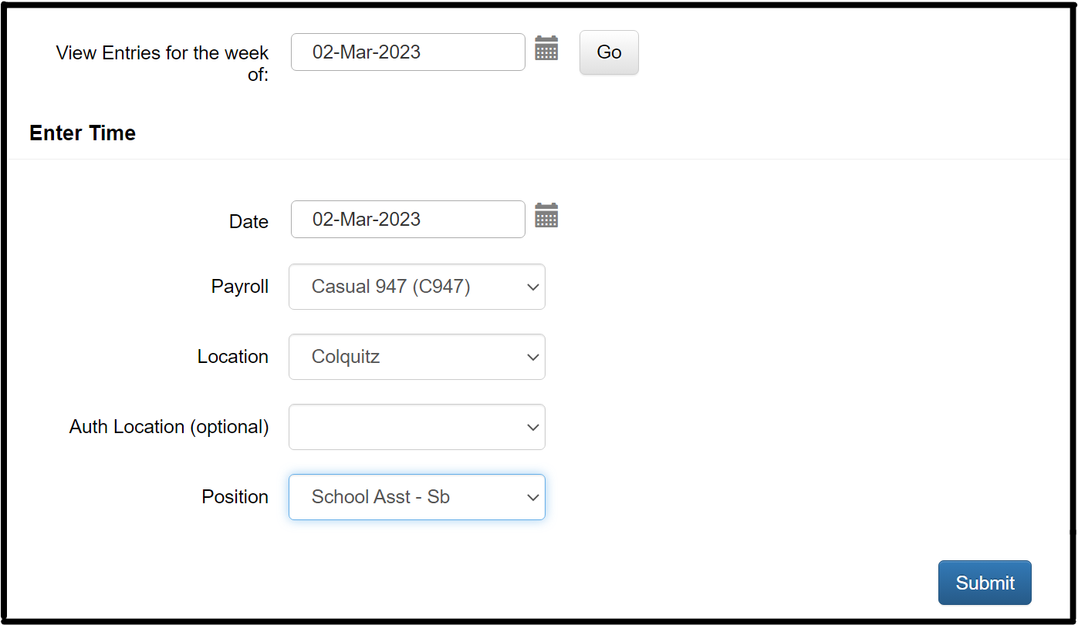

- Enter the number of hours you worked each day, for the position you selected for this timesheet.
- Enter hours in the “Replacement hours” row when you are replacing an absent Regular CUPE 947 employee.
- Enter hours in the “Extra hours” row when you are NOT replacing an employee. Your earnings for “Extra hours” are automatically charged to your school. Your Principal or SAA may advise you to enter a GL account number in the memo box next to your hours, or you would leave the Memo Box blank.
Memo box
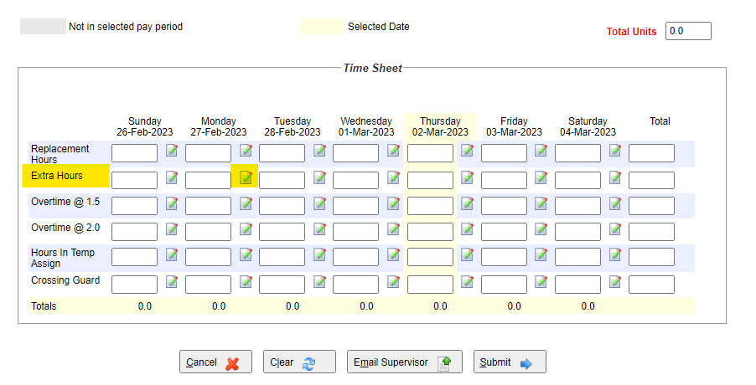
- Select “Submit”.

Reminders:
- A timesheet must be completed for each position and location:
  - If you work as an EAG at Colquitz on Monday – separate TEW timesheet
  - If you work as a DEA at Colquitz on Friday – separate TEW timesheet
  - If you work as a SPVN at Glanford Tuesday to Thursday – all on the same TEW timesheet
- You may look at your current week’s timesheet(s) or prior weeks timesheets from the “View Entries for the week of” box when you first enter TEW.
- No paper timesheets will be accepted unless there are exceptional circumstances.

