CUPE 947 12 MONTH EMPLOYEES – TIMESHEET ENTRY WEB (TEW) (Sept 2023 Ver)
Your timesheet can be found in eServices, under My Info > Time & Attendance > Enter Time > Select Timesheet Entry.
eServices is located on www.sd61.bc.ca . Select Staff > eServices.
If you do not know your password, please contact the Help Desk (250) 475-4188.

947 12-Month employees only need to complete a TEW timesheet if you have worked any time OTHER than your normal assigned hours. This is only for extra time worked such as Spring Break Accrual, Flex Time Accrual, EXTRA HRS / OT to be paid or EXTRA HRS / OT to be banked to be used later.
Timesheets for the week should be completed before the end of the day on Fridays. For most 12-month employees, you will only need to fill in one timesheet template. If you have more than one position, you will need a separate timesheet completed for each position and for each location.
Please see diagram below for instructions on completing your timesheet.
- The date will default to the current day. You may select any day in the week to see your timesheet.
- Choose Payroll by selecting Cupe 947 Payroll (Biwk) from the drop-down menu.
- Location should fill in from your current assignment, or use the drop-down menu (Note: your timesheet can only be seen, and authorized, by the location you choose)
- Auth Location (optional) – DO NOT select anything for this field, leave BLANK, if something populates, leave.
- Position should fill in from your current assignment, or use the drop-down menu (Note: Your rate of pay is driven by the position you choose)
- Select “SUBMIT”
NOTE: From the View Entries for the week of: box, you may view current and prior week’s timesheets
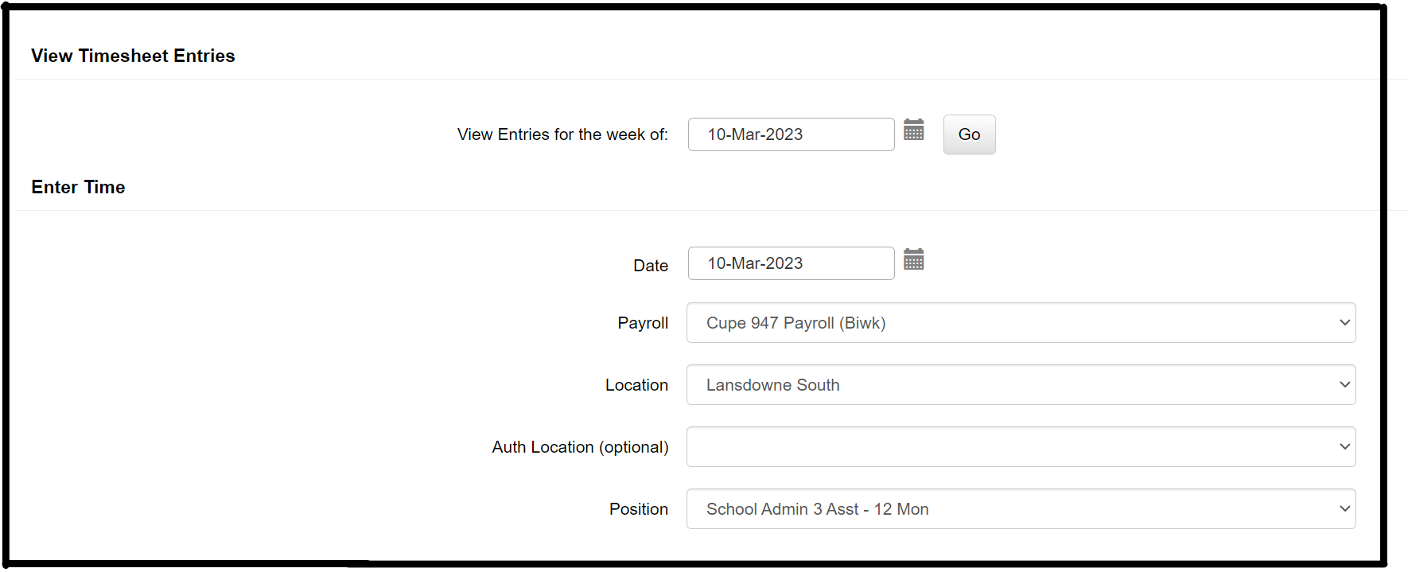

- Enter the number of ‘extra’ hours you worked each day, for the position you selected for this timesheet.
- Enter hours (portion of an hour) in the “Spring Break Earned” row when you are working the extra hours for Spring Break.
- Enter hours (portion of an hour) in the “Flex Time Earned” or “Extra / OT Hours Paid / Banked” row when you have worked extra hours. Your Principal or Authorizer may ask you to enter a GL account number in the memo box next to your hours, or you would leave the Memo Box blank.
Memo box
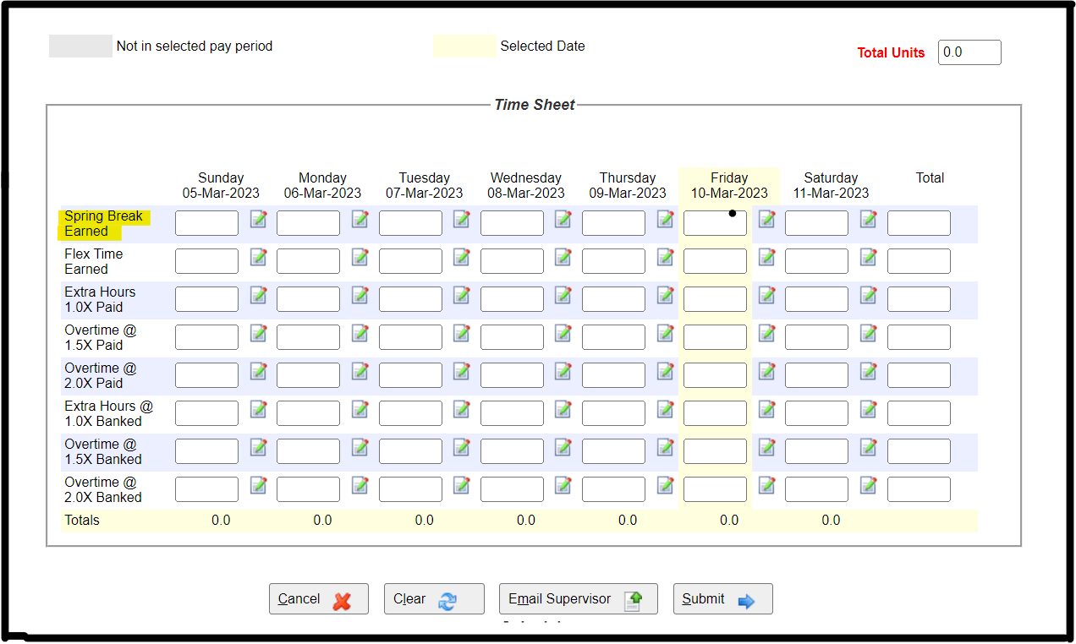
- Select “Submit”.

Reminders:
- A timesheet (TEW) is only required when you work hours above your assigned hours.
- You may look at your current week’s timesheet(s) or prior weeks timesheets from the “View Entries for the week of” box when you first enter on to the TEW page.
- No paper timesheets will be accepted unless there are exceptional circumstances.

