**CUPE 382 TRADES EMPLOYEES – TIMESHEET ENTRY WEB (TEW)**

Your timesheet can be found in eServices, under My Info > Time & Attendance > Enter Time > Select Timesheet Entry.

eServices is located on[*www.sd61.bc.ca*](http://www.sd61.bc.ca) *.* SelectStaff > eServices.

If you do not know your password, please contact the Help Desk.

**Timesheets for the week should be completed by Friday morning at 8:00 am. Ground staff that have more than one position, will need a separate timesheet completed for each position.**

Please see diagram below for instructions on completing your timesheet.

1. The date will default to the current day. You may select any day in the week to see your timesheet.
2. **Choose Payroll** by selecting **CUPE 382 Payroll (P382)** from the drop-down menu.
3. **Location** will default with Facilities Services.
4. Auth Location **– DO NOT** select anything for this field, it populates with correct info, (ignore).
5. **Position** defaults with your Position, only Grounds staff will change due to the position working by using the drop-down menu (Note: Your rate of pay is driven by the position you choose)
6. Select “SUBMIT”

*NOTE: From the View Entries for the week of: box, you may* ***view*** *current and prior week’s timesheets*

1. Enter the **number of hours** you worked each day, for the position you selected for this timesheet**.**

* Enter hours worked on the appropriate Line of the TEW template.
* Enter hours (portion of an hour) in the “Spring Break Earned” row when you are working the extra minutes for Spring Break.
* Enter hours (portion of an hour) in the “Overtime #.#x PAID” or “Overtime #.#x BANKED” row when you have worked extra hours. If the entry is on the PAID line, it will be paid out on the next pay run, if it’s entered on the BANKED line it will be added to your BANKED time storage bank.
* If you want to leave a comment on your entry, you can leave a comment in the Memo Box. Ie: WO#
* Enter hours of eBase

*Memo box*

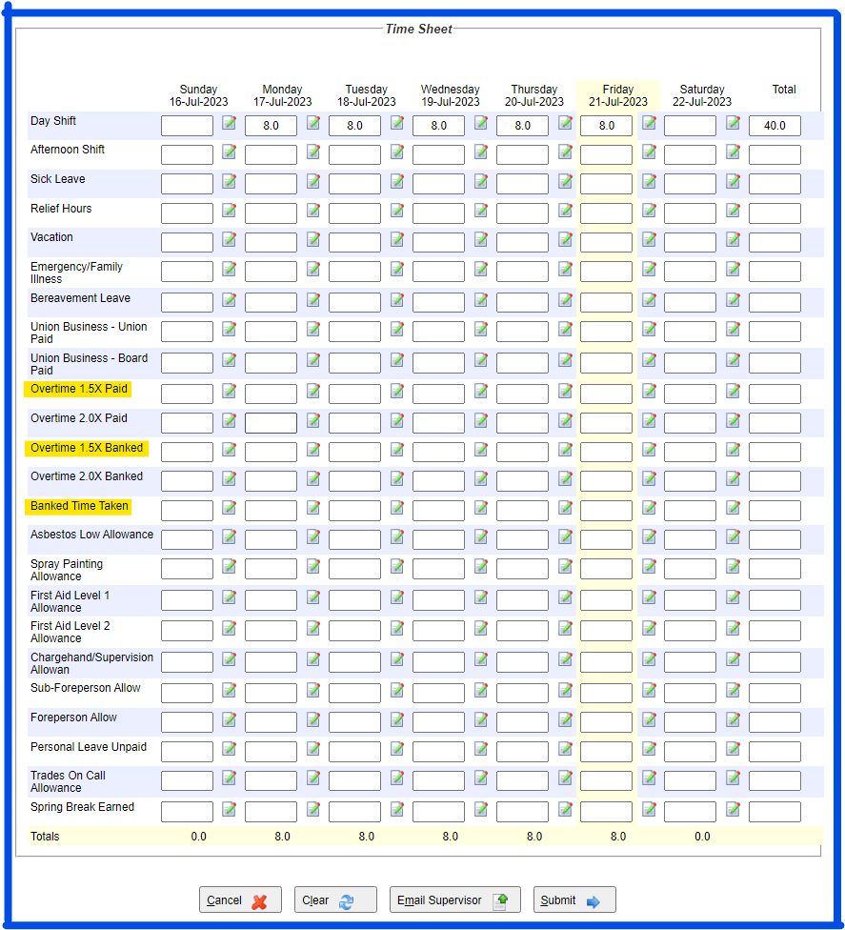

1. Select **“Submit”.**

Reminders:

* You may look at your current week’s timesheet(s) or prior weeks timesheets from the “View Entries for the week of” box when you first enter on to the TEW page.