**CUPE 382 CASUAL EMPLOYEES – TIMESHEET ENTRY WEB (TEW)**

Timesheets are now due WEEKLY! Electronically – No more paper, no more pictures!!

**These are to be completed every Thursday!! If you are in a long assignment please fill in the Friday and if a change happens the office will make that change. If you don’t know where you will be on Friday, please leave blank and we will complete for you.**

Your timesheet can be found in eServices, My Info, Time and Attendance – Enter Time.

*eServices is located on* [*www.sd61.bc.ca*](http://www.sd61.bc.ca) *. Select Staff. Select eServices.*

*If you do not know your password, please contact Human Resources* at 250-475-4239

Please see diagram below to complete your timesheet. From the **Payroll Selections section**:

NOTE: From the **Date Selection** box, you may **view** current and prior week’s timesheet submissions

* The date will default to today. You may select any day in the week to see your timesheet
* **Choose Payroll - select Casual 382 Payroll (C382) from the drop down menu**
* Everything should auto populate once the Casual 382 Payroll has been filled in. **If it does not auto populate** please contact the Facilities office at 250-920-3400 or text the dispatch phone for assistance.
* **DO NOT** touch ANY of the other fields.
* Select “Enter Time”

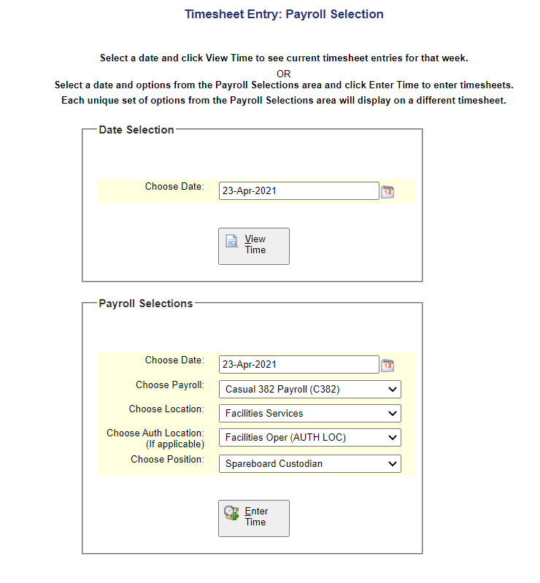

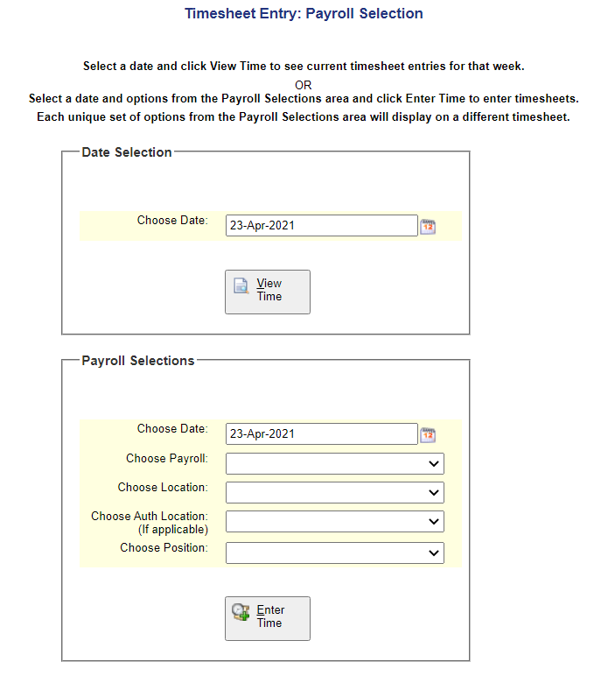

-2-

1. Enter the **number of hours** you worked each day, in the line that you were provided with via text when dispatched**. If advised put a comment in the memo box but otherwise leave blank**

*Memo box*

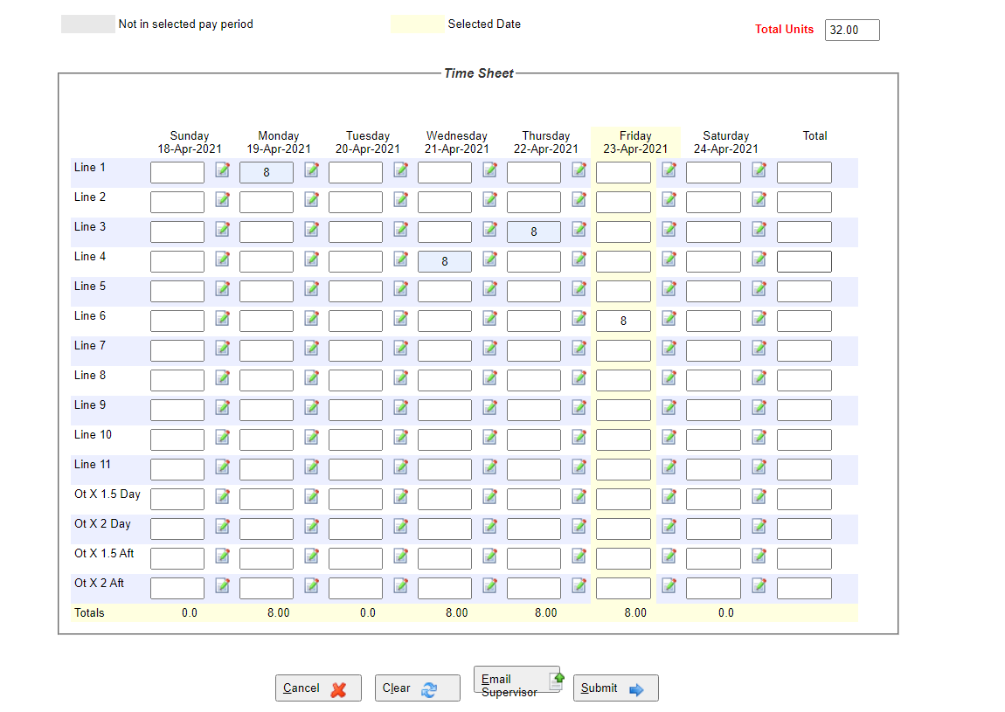

1. Select **“Submit”.**

It will review what you have entered and it will look like this:

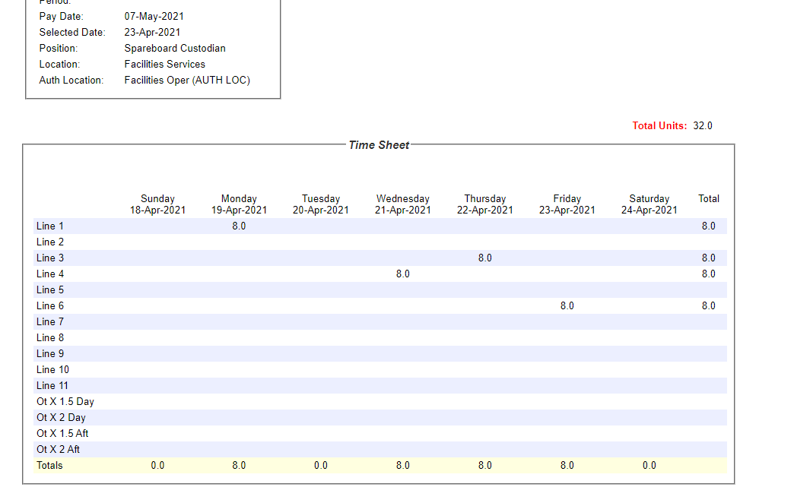

Your timesheet entry is now complete!

Reminders:

* A timesheet must be completed EACH WEEK.
* You may look at your current week’s timesheet(s) or prior weeks timesheets from the “Date Selection” box when you first enter TEW.

Any questions or concerns please contact:

* Your daytime foreman @ 250-514-6649
* Your evening foreman @ 250-727-8160
* The operations office @ 250-920-3450